# Calculating on a Pivot Table

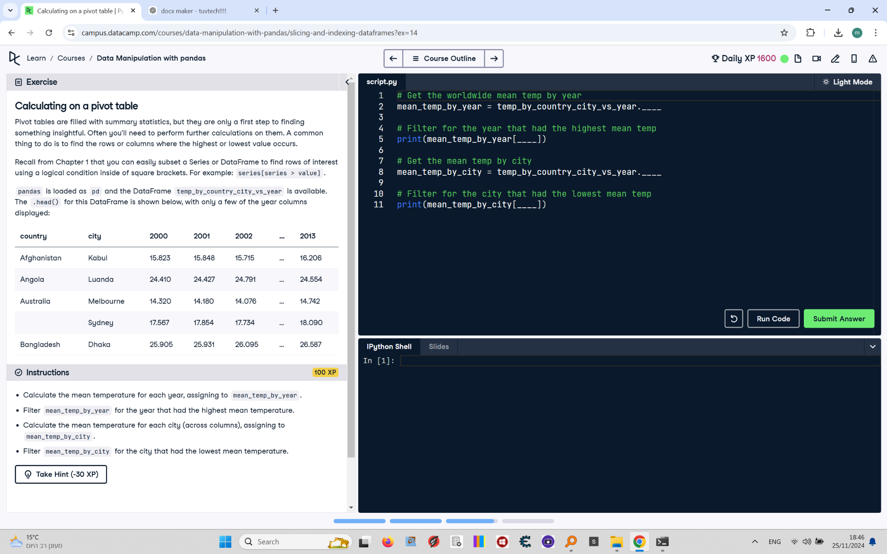

Pivot tables are filled with summary statistics, but they are only a first step to finding something insightful. Often you’ll need to perform further calculations on them. A common thing to do is to find the rows or columns where the highest or lowest value occurs.  
  
Recall from Chapter 1 that you can easily subset a Series or DataFrame to find rows of interest using a logical condition inside of square brackets. For example: series[series > value].  
  
pandas is loaded as pd and the DataFrame temp_by_country_city_vs_year is available.

## Final Answer

# Get the worldwide mean temp by year  
mean_temp_by_year = temp_by_country_city_vs_year.mean()  
  
# Filter for the year that had the highest mean temp  
print(mean_temp_by_year[mean_temp_by_year == mean_temp_by_year.max()])  
  
# Get the mean temp by city  
mean_temp_by_city = temp_by_country_city_vs_year.mean(axis="columns")  
  
# Filter for the city that had the lowest mean temp  
print(mean_temp_by_city[mean_temp_by_city == mean_temp_by_city.min()])